**CHAPTER 1**

**INTRODUCTION**

ARGICULTURE MANAGEMENT is a Database application which informs about the agriculture related aspects . This mini-Project is implemented using HTML and PHP. The project also showcases embedded multimedia and Cascaded Style Sheet.Operations supported by the application are insert, delete, update and retrieve. Admin has rights to insert, update and delete. This contains the information about crop and available seed types , suitable type of soil to cultivate them, uses of fertilizers to get good yield and pesticides to control the pests. This database system also contains information about warehouse which is helpful to store the agricultural products safely.In the following sections, a brief introduction about the tools, languages and the databases used to develop the project are discussed.

* 1. **HTML**

HTML, which stands for Hyper Text Mark-Up Language, is the language for describing structured documents as well as the language used to create web pages in the Internet. The language is based on an existing, international formatting standard SGML, Standard Generalized Mark-Up Language, which is used for text processing.

HTML documents are nothing but web pages which contains HTML tags and plain text. The purpose of a web browser is to read HTML documents and display them as web pages. The browser does not display the HTML tags, but uses the tags to interpret the content of the page.

## History

HTML, which stands for Hyper Text Mark-Up Language, is the language for describing structured documents as well as the language used to create web pages in the Internet. The language is based on an existing, international formatting standard SGML, Standard Generalized Mark-Up Language, which is used for text processing. HTML is a simplified version of SGML.

## Tools in order to use HTML

Tools help us in process of creating HTML document. Some are as follows

* TEXT EDITOR: To create the HTML code we require a text editor or a word processor. Such as, Notepad, WordPad. We are using notepad++ in developing this project.
* WEB BROWSER: The code created by an editor should be executed. This operation can be performed with help of a web browser. Such as Internet Explorer, Netscape navigator, Mozilla Firefox etc.
* GRAPHICS SOFTWARE: To include picture we require a graphic software like Adobe Photoshop.
* Web server: To make the document is to be available on the internet then, we will have to host it on a web server.

## **1.1.1 Significant Language Features**

HTML files are written in ACSII text, so the user can use any text editor to create his/her web page, though a browser of one sort or another is necessary to view the web page. HTML is case insensitive with its language commands. The characters within the document, however, are case sensitive. The language consists of various "tags" which are known as elements. These allow the browser to understand (and put into the desired/specified format) the layout, background, headings, titles, lists, text and/or graphics on the page. The elements are classified according to their function in the HTML document. There are head elements and body elements. The head elements identify properties of the entire document, while body elements actually mark text as content and show a change in the appearance in one way or another. Most elements have a beginning and an ending which encompass the text the user wishes to mark with the tag. All HTML documents must begin with the element and end with the element. Some of the other elements which may be used are tags to create lists--both ordered lists as well as unordered lists. The user may also create larger or smaller, bolder, italicized, or underlined text. Attributes may be used along with the elements. These perform functions such as placement of text, indication of the source files of images, and identification of links to the document or part of the document.

**1.1.2 HTML Code**

Copy and paste the following HTML code into your newly open text file. Which just displays hello world..

<html>  
<header><title>This is title</title></header>  
<body>  
 This is sample text...  
 <!-- We use this syntax to write comments -->  
 <!-- Page content and rest of the tags here.... -->  
 <!-- This is the actual area that gets shown in the browser →

Hello world  
</body>  
</html>

**1.1.3 HTML TAGS**

HTML tags are keywords surrounded by angle brackets like <html>. These are in pair format such that every first tag in pair is start tag where as second tag is end tag. These start and end tags are also called as opening tags and closing tags respectively.

**Tags Used In Project**

The HTML tags are the basis, in order to do this Project. By using some of the important and basically taught tags are used in this Project. Here are some of the tags used in making the Project called AUTOMOBILE MANAGEMENT SYSTEM.

HTML Attributes

Attributes provide additional information about HTML elements.

* HTML elements can have **attributes**
* Attributes provide **additional information** about an element
* Attributes are always specified in **the start tag**
* Attributes come in name/value pairs like: **name="value"**

Some basic text formatting HTML tags are listed:

|  |
| --- |
| **Tag Description** |
| <html> Defines an HTML document |
| <body> Defines the document's body |
| <h1> to <h6> Defines header 1 to header 6 |
| <p> Defines a paragraph |
| <br> Inserts a single line break |
| <b> Defines bold text |
| <!--> Defines a comment |
| <small> Defines small text |

Some of the HTML tags used to create a table are listed:

In an HTML file we can create tables with the Table tags, which in turn will render the browser to display the table in the web page.

|  |
| --- |
| **Tag Description** |
| <table> Defines a table |
| <th> Defines a table header |
| <tr> Defines a table row |
| <td> Defines a table cell |
| <tbody> Defines a table body |
| <tfoot> Defines a table footer |

**A Simple Form**

A form in a web page allows the users to input various data online. In an HTML document; forms can be created with the Form tags. In the following table, some basic Form tags are listed:

|  |
| --- |
| **Tag Description** |
| <form> Defines a form for user input |
| <input> Defines an input field |
| <textarea> Defines a text-area |
| <label> Defines a label to a control |
| <fieldset> Defines a fieldset |
| <legend> Defines a caption for a fieldset |
| <select> Defines a selectable list |
| <optgroup> Defines an option group |
| <option> Defines an option in the drop box |
| <button> Defines a push button |

**Image Tags**

In an HTML document we can insert and display images by using the image tags.

In the following table, some basic Image tags are listed:

**Tag Description**

<IMG SRC attributes> Defines an image

The “src” attribute is used to display an image on a web page. “src” stands for “source”, and its value is the url of the image to be displayed on the page. The url indicates the location where the image is stored. Attributes may be height, width, align so on.

**Background colour**

Using bgcolour attribute this can be done. This is body tag attribute. Six digit hexadecimal code represent the colours.

Syntax: <body text=”text_color” bgcolor = ”background_color”>

**Anchor tag**

Anchor tag is used to link two or more different web pages.

Ex: <a href=”next page to be opened”>click here</a> where href stands for hyper link reference.

## **Areas of Application**

HTML only has one area of application at this time and that is the development of web pages. However, not all browsers support all the tags in all versions of HTML. Because of this, it is wise not to design your web page for a specific browser, because what may look fantastic on your browser has no guarantee of looking great on someone else's browser.

**1.2 PHP**

PHP is a general-purpose scripting language that is especially suited to server-side web development, in which case PHP generally runs on a web server. Any PHP code in a requested file is executed by the PHP runtime, usually to create dynamic web page content or dynamic images used on websites or elsewhere.

PHP originally stood for Personal Home Page, but it now stands for the recursive backronym PHP. Hypertext Pre-processor. PHP code may be embedded into HTML code, or it can be used in combination with various web template systems, web content management system and web frameworks.

**PHP developer**

PHP developers develop programs, applications, and web sites using the dynamic scripting language PHP. PHP is known for web development and business applications. Depending on job function, PHP developers may be classified as software developers or web developers.

**Tags Description**

 <?php to open PHP section

?>  to close PHP sections

ECHO prints the lines

**1.3** **DATABASE**

A database is a collection of [information](http://searchsqlserver.techtarget.com/definition/information) that is organized so that it can easily be accessed, managed, and updated. In one view, databases can be classified according to types of content: bibliographic, full-text, numeric, and images. **Database** software systems are programmed in SQL, and examples include Microsoft SQL Server, MySQL, Oracle SAP HANA and FoxPro.

A DBMS system is also required to protect the integrity of data and provide its security. A database management system (**DBMS**) is system software for creating and managing databases. The **DBMS** provides users and programmers with a systematic way to create, retrieve, update and manage data.

**1.4 MYSQL**

MySql is a powerful database. It's very good and free of charge. Many developers in the world selected mysql and php for developing their website.

The MySQL database has become the world's most popular open source database because of its consistent fast performance, high reliability and ease of use. It's used in more than 6 million installations ranging from large corporations to specialized embedded applications on every continent in the world. (Yes, even Antarctica!)

Not only is MySQL the world's most popular open source database, it's also become the database of choice for a new generation of applications built on the LAMP stack (Linux, Apache, MySQL, PHP / Perl / Python.) MySQL runs on more than 20 platforms including Linux, Windows, OS/X, HP-UX, AIX, Netware, giving you the kind of flexibility that puts you in control.

Whether you're new to database technology or an experienced developer or DBA, MySQL offers a comprehensive range of certified software, support, training and consulting to make you successful.

**1.5 WAMP**

The acronym WAMP refers to a set of free ([open source](http://www.webopedia.com/TERM/O/open_source.html)) [applications](http://www.webopedia.com/TERM/A/application.html), combined with Microsoft Windows, which are commonly used in [Web server](http://www.webopedia.com/TERM/W/Web_server.htm) environments. The WAMP stack provides developers with the four key elements of a Web server:  an [operating system](http://www.webopedia.com/TERM/O/operating_system.htm), [database](http://www.webopedia.com/TERM/D/database.html), Web server and Web scripting software. The combined usage of these programs is called a server stack. In this stack, [Microsoft Windows](http://www.webopedia.com/TERM/M/Microsoft_Windows.html) is the operating system (OS), [Apache](http://www.webopedia.com/TERM/A/Apache_Web_server.html) is the Web server,  [MySQL](http://www.webopedia.com/TERM/M/MySQL.html) handles the database components, while [PHP](http://www.webopedia.com/TERM/P/PHP.html), [Python](http://www.webopedia.com/TERM/P/Python.htm), or [PERL](http://www.webopedia.com/TERM/P/Perl.html) represents the dynamic scripting languages.

**1.6 Notepad++**

Notepad**++** is a [text editor](https://en.wikipedia.org/wiki/Text_editor) and [source code editor](https://en.wikipedia.org/wiki/Source_code_editor) for use with [Microsoft Windows](https://en.wikipedia.org/wiki/Microsoft_Windows). Unlike [Microsoft Notepad](https://en.wikipedia.org/wiki/Microsoft_Notepad), the built-in Windows text editor, it supports [tabbed](https://en.wikipedia.org/wiki/Tab_(GUI)) editing, which allows working with multiple open files in a single window. The project's name comes from the [C](https://en.wikipedia.org/wiki/C_(programming_language)) [increment operator](https://en.wikipedia.org/wiki/Increment_operator).

Notepad++ is distributed as [free software](https://en.wikipedia.org/wiki/Free_software). At first the project was hosted on [SourceForge.net](https://en.wikipedia.org/wiki/SourceForge.net), from where it has been downloaded over 28 million times.

**1.7 Web Browser**

**Google Chrome** is a free **web browser** from Google which we are using here. With its clean design and advanced features, Chrome has quickly become one of the most popular web browsers worldwide. In this lesson, we'll talk about the **features of Google Chrome**, how to **download and install Chrome** to your computer, and how to **sign in to Chrome** using a Google account.

**CHAPTER 2**

**System Analysis and Design**

In this chapter, a complete description of the project development is discussed. The requirements of the project identified are showcased. The database design is done Using High-Level Conceptual Data Models

###### 2.1 Requirement Analysis

Following requirements were identified during the requirement collection and analysis.

1. CROP: To maintain the record of crop, the details of each crops should be maintained. It consists of: crop_id -each crop is given a unique id. crop_id is considered to be the primary key of entity crop .The name , quantity of the crop is specified as crop_name , cquantity respectively.
2. SOIL: To maintain the record of soil, the details of each soil should be maintained. It consists of soil_id : each soil is given a unique id. In this schema , soil_id is connected to be the primary key of entity soil. The name ,features of the soil is specified in the attribute as soil_name , features respectively and crop_id which is to be cultivated in particular soil is considered.
3. PESTICIDE: To maintain the record of pesticide, the details of each pesticide should be maintained. It consists p_id : each pesticide is given a unique id which is generated. In this schema p_id is considered to be primary key of entity pesticide. The name, rate, quantity of pesticide is specified as pname , prate, pquantity respectively and crop_id of crop is also considered.
4. SEED: To maintain the record of seed ,details of each seed should be maintained. It consists of seed_id .Each seed is given a unique id which is generated .In the schema seed_id is considered to be the primary key of entity seed. The name, quantity, type of seed is specified in the attributes as seed_name , seed_quantity , seedtype and crop_id of crop is also considered.
5. WAREHOUSE: To maintain the record of warehouse, the details of each warehouse should be maintained. It consists of w_id :each warehouse is given a unique id which is auto generated. In this schema w_id is considered to be primary key of the entity warehouse. The name, capacity, address of the warehouse is specified in the attributes as wname, capacity, waddress respectively and crop_id is also considered.
6. FERTILIZER: To maintain the record of fertilizer, the details of each fertilizer should be maintained. It consists of f_id :each fertilizer is given a unique id which is auto generated. In this schema f_id is considered to be the primary key of entity fertilizer. The name, quantity, rate of the fertilizer is specified in the attribute as fname, pquantity, prate respectively and soil_id is also considered.

### Feasibility Study

### The feasibility study carried out showed that the requirements that were to be included could be provided by the use of RDBMS software such as MySQL which is available as an open source and for the front end HTML pages with processing capability provided by the Scripting language such as PHP and Javascript.

**2.2 ER-Diagram**

Following is the conceptual representation of the requirements identified as an ER-Diagram

SOIL

PESTICIDE

**n n m**

NEEDS

NEEDS

NEEDS

m n

m

FERTILIZER

CROP

1

STORED IN

I

IND

REQUIRES

n

WAREHOUSE

n m m

SEED

**Figure 2.1 ER Diagram for Agriculture Management System**

**2.3 Relational Schema**

The relational schema diagram has been derived from the ER-Diagram in Figure 2.1 using the ER-Relational mapping algorithm

**CROP**

|  |  |  |
| --- | --- | --- |
| crop_id | crop_name | cquantity |

**SOIL**

|  |  |  |  |
| --- | --- | --- | --- |
| soil_id | soil_name | features | crop_id |

**PESTICIDE**

|  |  |  |  |  |
| --- | --- | --- | --- | --- |
| p_id | Pname | Prate | pquantity | crop_id |

**SEED**

|  |  |  |  |  |
| --- | --- | --- | --- | --- |
| seed_id | seed_name | squantity | seedtype | crop_id |

**WAREHOUSE**

|  |  |  |  |  |
| --- | --- | --- | --- | --- |
| w_id | wname | capacity | waddress | crop_id |

**FERTILIZER**

|  |  |  |  |  |
| --- | --- | --- | --- | --- |
| f_id | Fname | fquantity | frate | soil_id |

**Figure 2.2 Relational Schema Diagram Showing the Primary key and Foreign key relationships**

**2.4 Functional Requirements**

Functional requirements of a software project interpret the function of a part. It defines its functions, input and output. The typical functional requirements include:

Application contains 2 modules:

* Admin module
* User module

Admin module

* Admin can register the product information.
* Admin can insert the product information.
* Admin can delete the product information.
* Admin can update the product information.

User module

* User can register to the application.
* User can view the product information.
* User can search the product present or not.

**2.5 Non- Functional Requirements**

A non-functional requirement specifies the canon of the articular process not the particular judgment of the system and particular behavior of the process. Non-functional requirements define how the system works.

* This application is developed to automate the complete operations of storing the agriculture related information.
* Since searching is expected to be faster so one can find required details instantly ,this system helps in the cause.
* The objective of this project is to develop a computerized project through which we can reduce human efforts.
* Using of application is secure, because it display appropriate information about the product scanned.
* The system should capable to enhance with further technology in future to improve its features compared to the existing system .
* The system should be reliable and it should be related in all the condition and it should be recoverable in all the situation or condition if error occurs.

**2.6 Use Case Diagram**

The use case diagrams usually refer to behavioral diagrams helps people to understand the interaction between user and system. Use case diagram identify different users of the system.It is used to define some set of actions, which is called as use cases.Actors are the result of some valuable use cases.Use case figures are also called as unified modeling language.

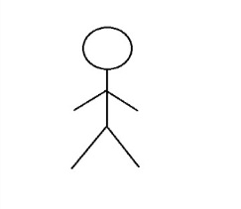

Admin

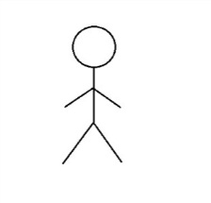

USER

**Figure 2.4 Use Case Diagram**

**CHAPTER 3**

**SYSTEM IMPLEMENTATION**

In this chapter, complete information of project is discussed and also the create command used, and what are all the code we are used and how the database connectivity is done all discussed.

**3.1 Database Design**

--Table structure for table crop--

CREATE TABLE ‘crop’(

crop_id int ,

crop_name varchar(15) ,

cquantity int,

constraint pk1 primary key(crop_id)

);

--Table structure for table ‘soil’--

create table soil(

soil_id int ,

soil_name varchar(15) ,

features varchar(30) ,

crop_id int,

constraint pk2 primary key(soil_id),

constraint fk2 foreign key(crop_id) references crop(crop_id)

);

--Table structure for table ‘pesticide’--

create table pesticide(

p_id int,

pname varchar(15) ,

prate int,

pquantity int,

crop_id int,

constraint pk3 primary key(p_id),

constraint fk3 foreign key(crop_id) references crop(crop_id)

);

--Table structure for table ‘seed’--

create table seed(

seed_id int,

seed_name varchar(15),

squantity int,

seed_type varchar(10),

crop_id int,

constraint pk4 primary key(seed_id),

constraint fk4 foreign key(crop_id) references crop(crop_id)

);

--Table structure for table ‘warehouse’--

create table warehouse(

w_id int,

wname varchar(15),

capacity int,

waddress varchar(15),

crop_id int,

constraint pk5 primary key(w_id),

constraint fk5 foreign key(crop_id) references crop(crop_id)

);

--Table structure for table ‘fertilizer’--

create table fertilizer(

f_id int,

fname varchar(15),

fquantity int,

frate int,

soil_id int,

constraint pk6 primary key(f_id),

constraint fk6 foreign key(soil_id) references soil(soil_id)

);

**3.2 Database Connectivity**

<?php

$host = "localhost";

$user = "root";

$pass = "";

$db = "agri";

$dbconn = mysqli_connect($host,$user,$pass,$db) or die("Could not connect to database!");

mysqli_select_db($dbconn,'crop');

$query="SELECT * FROM crop";

$result=mysqli_query($dbconn,$query);

$rownum=mysqli_num_rows($result);

?>

**3.3 Implementation of Database Operations**

INSERT

$add="INSERT INTO crop VALUES('$crop_id','$crop_name','$cquantity')";

mysqli_query($dbconn,$add);

$affectedrows = mysqli_affected_rows($dbconn);

if($affectedrows==1){

header("Location:crop.php");

}

UPDATE

$update_Query = "UPDATE crop SET crop_name='$crop_name', cquantity='$cquantity' WHERE crop_id='$crop_id'";

mysqli_query($dbconn,$update_Query);

$affectedrows = mysqli_affected_rows($dbconn);

if($affectedrows==1){

header("Location:crop.php");

}else {

$edit_crop_id = $_GET["crop_id"];

$edit_Query="SELECT crop_name,cquantity FROM `crop` WHERE `crop_id`='$edit_crop_id'";

$edit_Pass_Query = mysqli_query($dbconn, $edit_Query);

$edit_Results = mysqli_fetch_assoc($edit_Pass_Query);

}

DELETE

$crop_id=$_GET["crop_id"];

mysqli_query($dbconn,"DELETE FROM crop WHERE crop_id='$crop_id'");

$affectedrows = mysqli_affected_rows($dbconn);

if($affectedrows==1){

header("Location:crop.php");}

RETRIEVAL

<?php

$host = "localhost";

$user = "root";

$pass = "";

$db = "agri";

$dbconn = mysqli_connect($host,$user,$pass,$db) or die("Could not connect to database!");

mysqli_select_db($dbconn,'crop');

$query="SELECT * FROM crop";

$result=mysqli_query($dbconn,$query);

$rownum=mysqli_num_rows($result);

?>

**CHAPTER 4**

**Results and Discussion**

In this chapter the results of the project are discussed. The snapshot of the project showing various functionalities like insert, delete, update and retrieval are showcased.

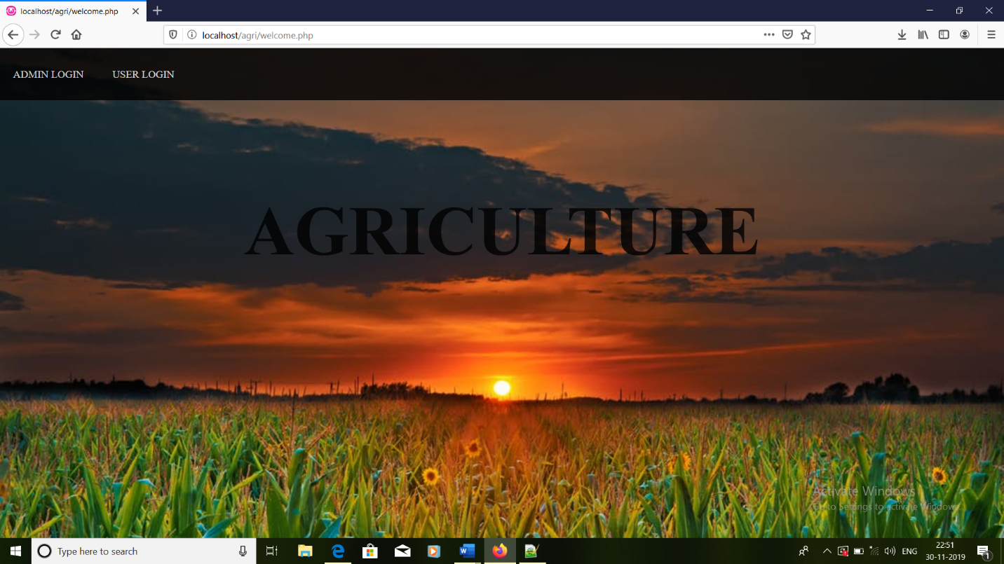

**Fig. 4.1 Welcome page of project**

Figure 4.1 shows the welcome page of the project. In this page we have options such as login for admin and for users .If the admin log in to the page then he can edit the values. If the person is clicks user login then he can only view the information of the table.

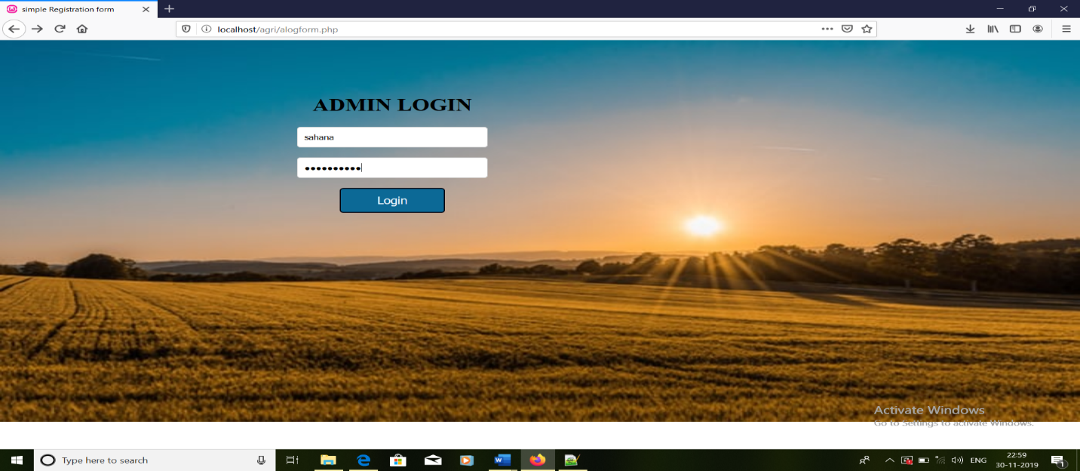

**Fig. 4.2 admin login page**

Figure 4.2 shows the admin login page of the project. In this page if the password and username is as that of the password and username admin then he/she is given access to perform operations on the table.

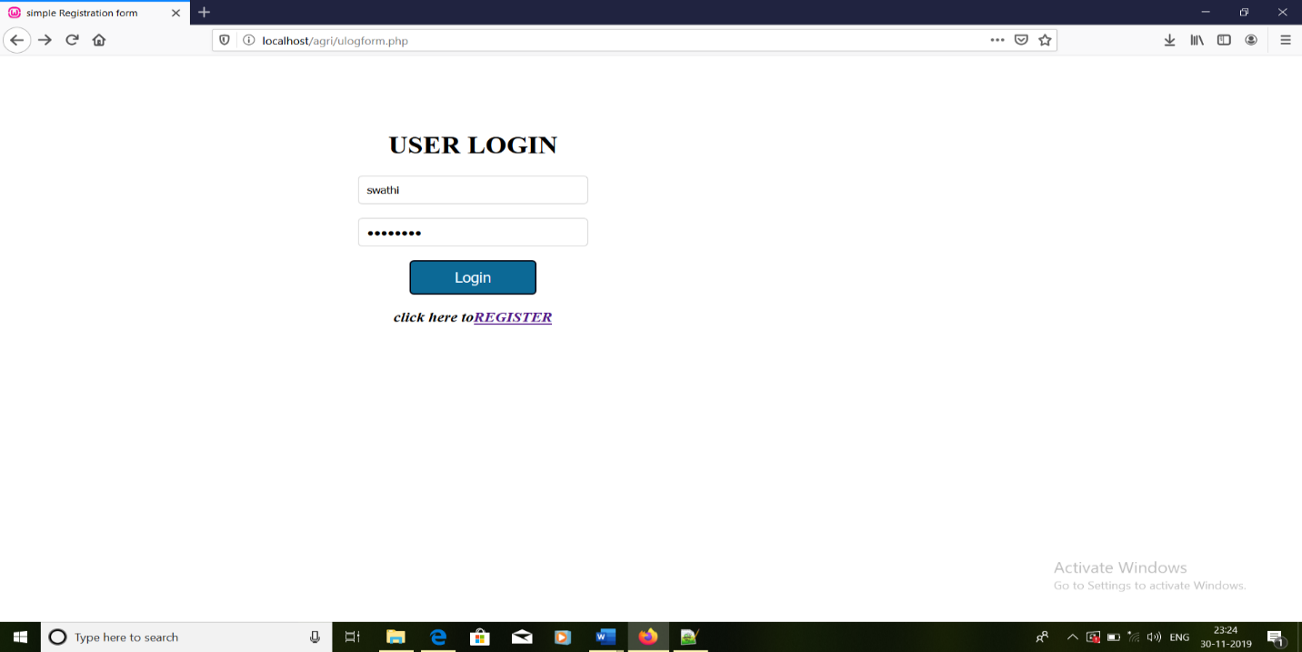

**Fig. 4.3 user login page**

Figure 4.3 shows the user login page of the project. In this page the user has to register first ,during registration he/she should give password .At the time of login if he enters the same username and password as that of registered then he will be given access to view information.

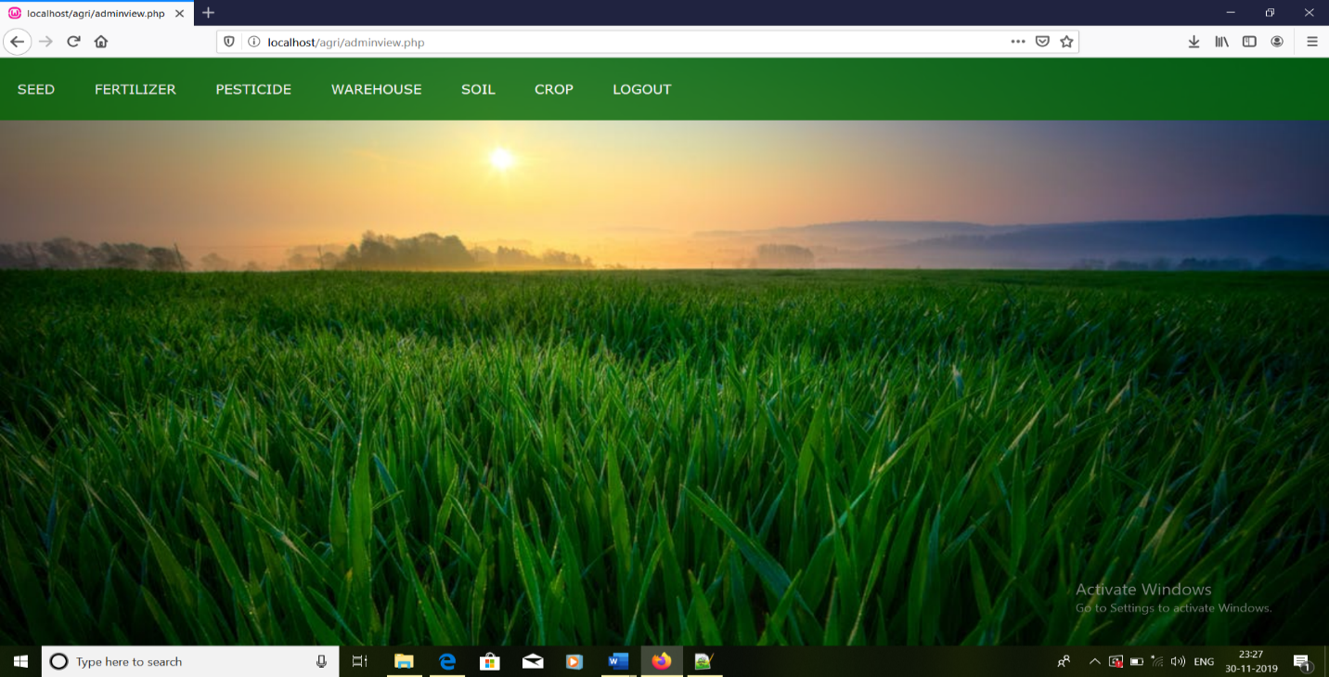

**Fig. 4.4 admin welcome page**

Figure 4.4 shows the admin welcome page of the project. In this page the admin is given access to all the pages on which he can perform operations such as insert,delete and updation.

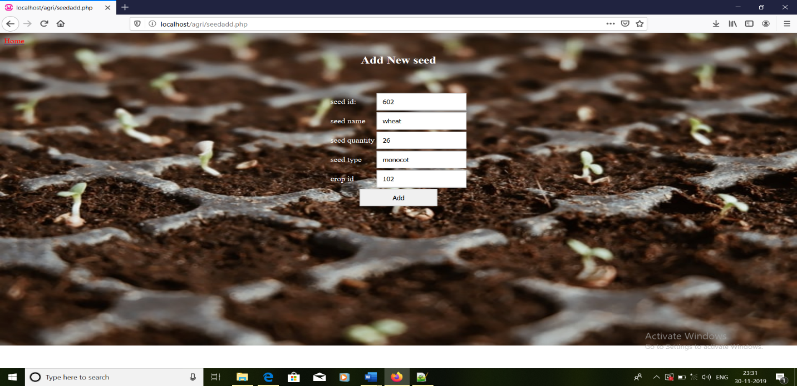

Fig 4.5:page for adding values

Fig 4.5 shows the admin page of the project.In this page admin can insert values.

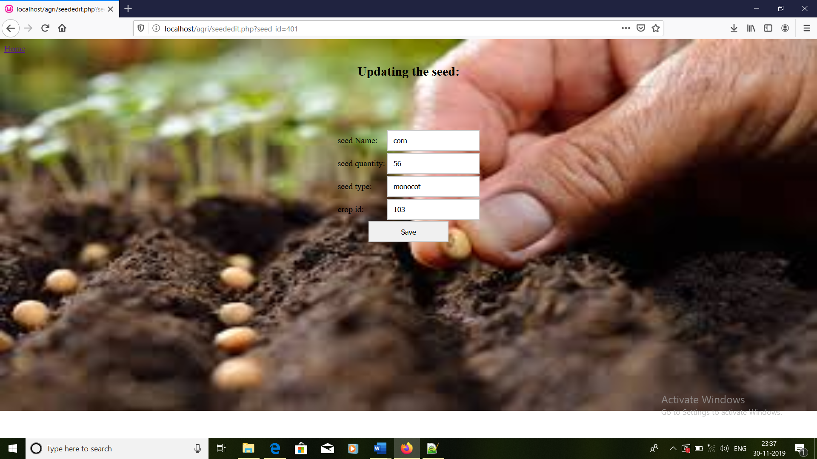

**Fig. 4.6 table for updating values**

Fig 4.6 shows admin page of the project .In this page admin can update the information.

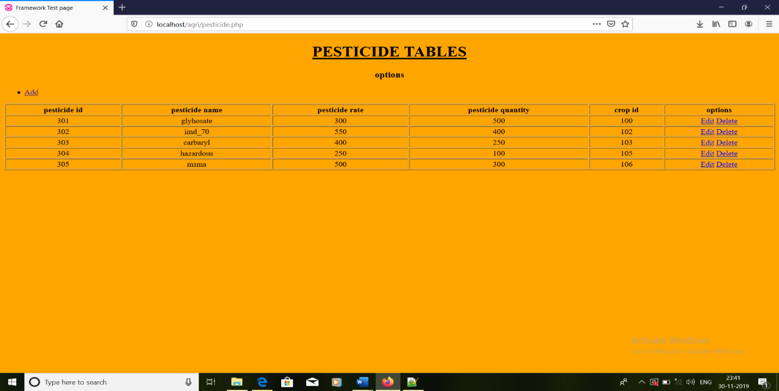

**Fig. 4.7 Retrieving the table information**

Fig 4.7 shows the admin page of the project.In this page admin can view the information.

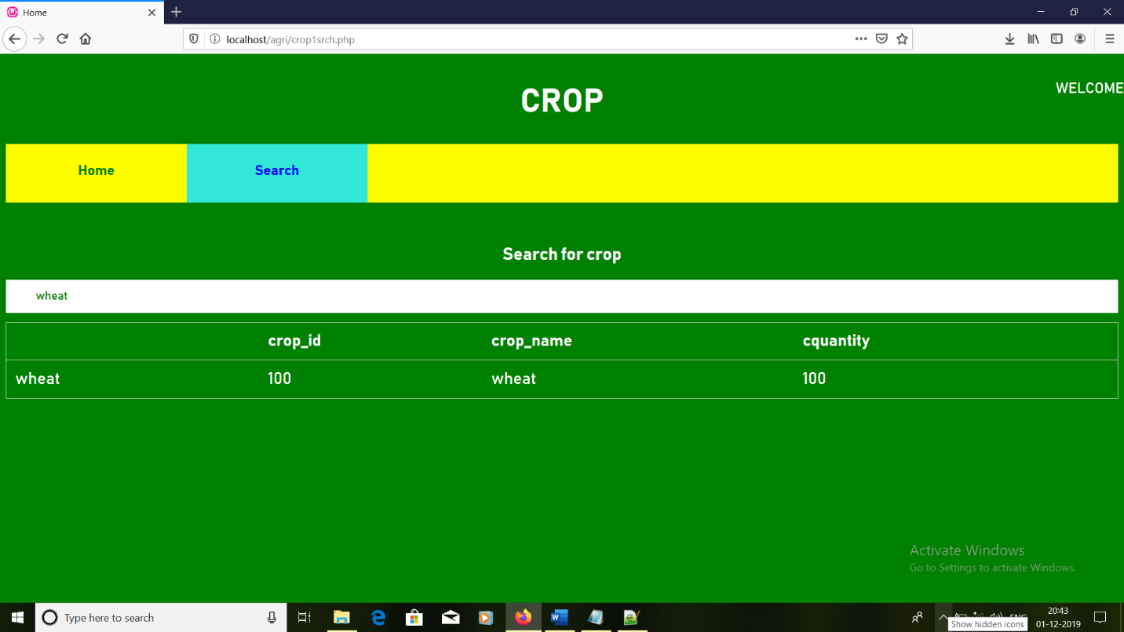

**Fig 4.8 searching the information in table**

Fig 4.8 The search option is only used by user . The information of products will be given when the user search through product name ,if the product is present it shows the product details. If it is not present it shows blank indicates that there no such product available. From this page we can go back to home or welcome page

**CHAPTER 5**

**CONCLUSION**

Agriculture database management helps us to know how the agriculture database is maintained,the study of data reduces the response time. The theoretical process involved in database design has been practically implemented. The project provides user friendly interface for the users to interact with the database. All database operations including insertion, deletion, updation and Retrievals are supported.

**REFERENCES**

[1]Database systems Models, Languages, Design and Application Programming, RamezElmasri and Shamkant B. Navathe, 7th Edition, 2017, Pearson.

[2] W3Schhols: [www.w3schools.com](http://www.w3schools.com)

[3] wikipedia